LHA award 2026

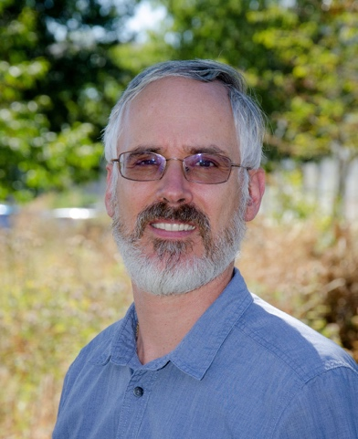
Valéry Masson (LHA) — Senior Researcher at Météo-France/CNRM, France, and internationally recognised leader in urban climate modelling and climate services.

He is internationally recognised for pioneering urban climate modelling, notably through development of the Town Energy Balance (TEB) model. His career has bridged fundamental urban climatology, operational weather prediction, climate adaptation and urban climate services, alongside major international leadership through WMO initiatives and the IPCC Special Report on Climate Change and Cities.

Bio: Valéry Masson is a researcher at CNRM, Toulouse, France, He developed the TEB urban canopy model in 2000 and conducted numerous experimental campaigns to study urban climates and urban heat islands. He aims to improve weather forecasting in cities. Many meteorological centres in Europe and Canada now use TEB. Recently he led the “Paris 2024 Olympics” WMO project, to prepare the way for future weather forecasting systems at infra-urban scales. He has also coordinated interdisciplinary research projects on the adaptation of cities to climate change for 15 years. To help city stakeholders to adapt cities, he has contributed to four WMO guides on urban climate services and is Lead Author of the IPCC special report on Climate Change and Cities.

TOA Award 2026
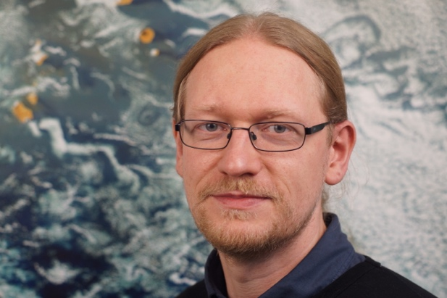
Björn Maronga (ToA) — Professor and Head of Department at Leibniz University Hannover, Germany, specialising in urban climatology, boundary-layer meteorology and LES modelling.

Björn Maronga is recognised for his leading role in developing PALM and PALM-4U into a world-leading building-resolving large-eddy simulation platform. His work integrates urban flow, radiation, vegetation, surface energy balance, air quality and thermal comfort, substantially advancing both fundamental urban climate science and the application of high-resolution modelling to climate-resilient urban planning.

Bio: Björn Maronga is Professor of Boundary-Layer Meteorology at Leibniz University Hannover and Managing Director of its Institute of Meteorology and Climatology. His research focuses on urban climate, atmospheric turbulence, and the interactions between cities and the atmospheric boundary layer. He has played a leading role in developing PALM and PALM-4U, a building-resolving large-eddy simulation system used internationally to investigate urban heat, airflow, pollutant dispersion, and climate-adaptation strategies at neighbourhood and city scales.

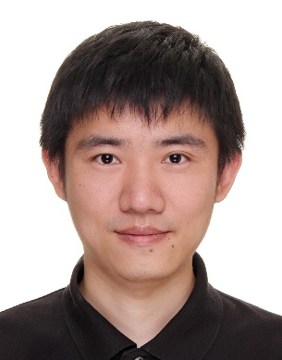
Yifan Fan (ToA) — Research Professor at Zhejiang University, China, specialising in urban climate, built environments, heat-dome dynamics and climate-resilient cities.

Yifan Fan is recognised for his original contributions to understanding urban heat-dome circulation. Combining physical theory, numerical modelling and innovative water-tank experiments, his research has revealed fundamental mechanisms governing plume-to-dome transitions, urban morphology effects and Coriolis deflection. His work has advanced understanding of urban ventilation, heat accumulation and pollutant dispersion under low-wind conditions.

Bio: Yifan Fan is a Research Professor at Zhejiang University, specializing in urban climate, low-carbon buildings, and resilient cities. He has published over 90 papers in internationally renowned journals, including Nature Communications, Building and Environment, Energy and Buildings, Urban Climate, and Sustainable Cities and Society. One of his papers was selected as an IAUC Feature Article. He serves as Associate Editor of the journal City and Built Environment and has received the Springer Nature Editor of Distinction Award. He also won the Second Prize of the Zhejiang Provincial Science and Technology Progress Award.

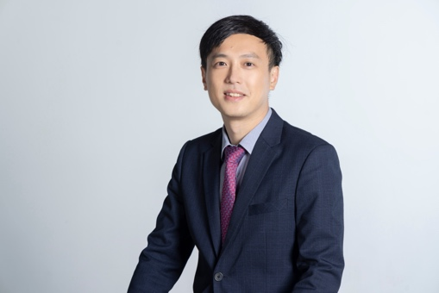
Jiachuan Yang (ToA) — Associate Professor at HKUST, Hong Kong, researching urban climate, heat and moisture transport, urban sustainability and multi-scale environmental modelling.
Jiachuan Yang is recognised for advancing multi-scale urban climate modelling, particularly through major developments of the WRF-Urban system. His contributions include improved representation of urban hydrology, green roofs, building energy and human thermal comfort, complemented by research on green infrastructure, electric vehicles and urban heat exposure, connecting fundamental urban physics with practical climate adaptation and sustainability.
BIO: Prof. Jiachuan Yang is an Associate Professor at The Hong Kong University of Science and Technology (HKUST), whose research focuses on urban climate and environmental systems. His work seeks to unravel complex urban–atmosphere interactions through the development of numerical modeling tools and, more recently, data-driven and artificial intelligence approaches. By integrating physical understanding with emerging computational methods, his research ultimately aims to support the development of more climate-resilient and sustainable cities.

